 | SITE  Standard Operating Procedure | Material Master Data |  | Revision  001
SOP Owner: Data Governance team  Data Owner: Operations Finance | Effective Date: |  | Page 1 of 25
TITLE: Cost –Roll process

DOCUMENTATION VERIFICATION
Prior to using this document, the user is responsible for verifying that the revision and effective date are current.

APPROVALS
All approvers listed shall approve the steps below:
DEPARTMENT | APPROVER FOR STEPS
GDG | Creation / Amendment
Finance Operations | Creation / Amendment

REVISION HISTORY
Periodic Review Schedule: 1 year from Effective date
No previous revision document currently available.
REVISION NUMBER | EFFECTIVE DATE | CHANGES MADE TO DOCUMENT
001 |  | N/A

CONTENTS
- PURPOSE ……………………….............................................................................. Page 3
- SCOPE ………………………………………………………………………………………………………… Page 3
- DEFINITION .……………………………………………………………………………………………….. Page 3
- RULES AND IMPACT FOR THE BUSINESS ………………………………………………………. Page 4
- RESPONSIBILITIES – Data Owners ……………………………………………………………..… Page 25
- DATA GOVERNANCE PROCESS …………………………………………………………………….. Page 25

- PURPOSE
To ensure that there is a consistent global approach to create/ change and govern the Material Master Data in SAP.

- SCOPE

This document applies to all Departments and teams who are responsible for the management and governance of the completeness and accuracy of this Data.

- DEFINITION
The cost-roll process is applied in order to set the standard cost/ price of a material or group of materials.
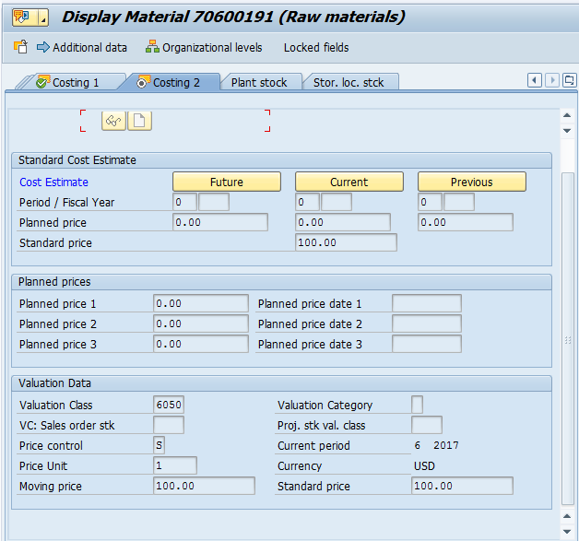
SAP transaction (T) codes:-
- ‘CK11N’ to ‘create a material cost estimate’
- ‘CK24’ to ‘mark a standard price’
- ‘CK24’ to ‘release a standard price’ (same T code as ‘b’)
- ‘MM03’ to view Material Master data
- ‘ZSCM_BOMECM’ to extract a multi-level BoM (initial user access may be a problem!)
Note:- the following process can be used to cost roll an individual or group of materials & assumes that all of the costing data has been correctly applied in either Material Master, Purchase Info Records (PIR) or that an existing reliable standard has previously be posted. Error resolution is partially covered on the last page.
As a general note, SAP adopts the following hierarchy when attempting to determine costs – if no costs can be determined, then a red error will be identified using a formal traffic light system.
- Material Master, Costing 2 tab, Planned Price 2 (legal) & Planned Price 3 (group) with associated ‘valid from dates’.
- PIR
- Existing Standard – seen in Material Master, costing 2 tab.

- RULES AND IMPACT FOR THE BUSINESS
Process to cost roll a single material
Select SAP ‘T’ code CK11N (either by typing in the dialogue box or from user defined ‘favourites’) & double click LH mouse or press ‘enter’.
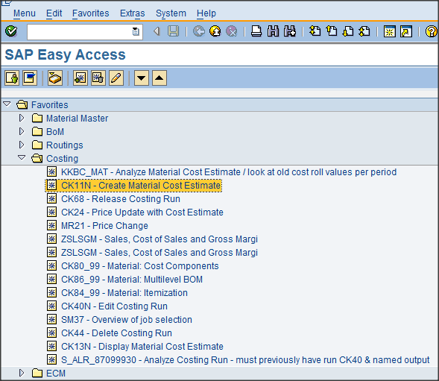f

The following screen results – note, some fields may already be populated by SAP depending on the ‘users’ last transaction or material searches.
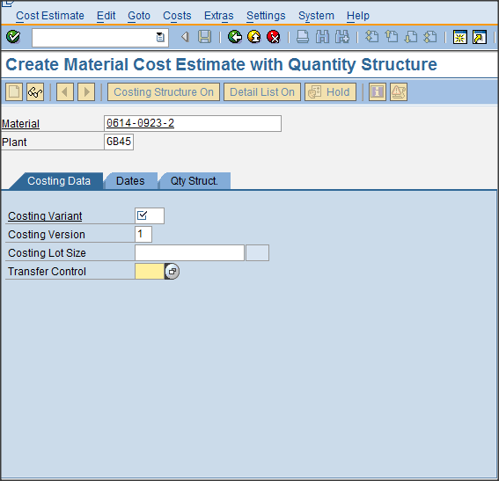
Add the relevant material number & plant in which the cost roll is to be conducted – in this instance the material is 0614-0923-2 & the plant GB45.
The costing activity requires that values be posted for both ‘Group’ & ‘Legal’ valuation. This necessitates that the correct ‘Costing Variant’ be selected - the acceptable values shown below are prefixed ‘Z’. Note that the manufacturing / service entities have specific values & for non- manufacturing sites ‘ZGRP’ & ‘ZLEG’ are available.
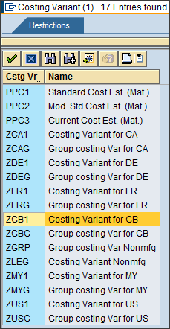

For the given material, ZGB1 will be selected to conduct a legal cost estimate in GB45
The costing version can remain as ‘1’ & the costing lot size as ‘blank’ which subsequently defaults to 1 (although the field remains blank). If a lot size greater than 1 is required then apply the relevant value.
Once the data has been populated, note that the transfer control box may be populated with the value ‘PC02’. This will instruct SAP to only cost roll this material. If you are attempting to cost roll a material & its underlying BoM (Bill of Material) then delete ‘PC02’.
The example below is set to cost roll a single externally procured material.
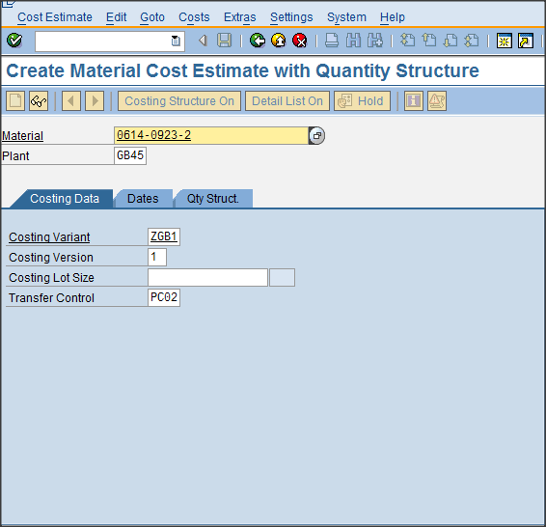
Click the ‘green’ tick icon (or hit enter) & the following screen will be revealed.
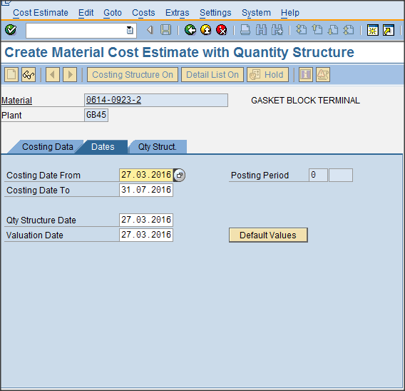
The ‘dates’ should now be considered: in the example the dates are suggesting that the cost roll will be posted in the next period. If you require the cost roll in the current period then amend ‘Costing date from’, ‘Qty structure date’ & ‘Valuation date’ to the current date (in this instance 2nd March 2016 (GB format)) as seen in the following screen shot.
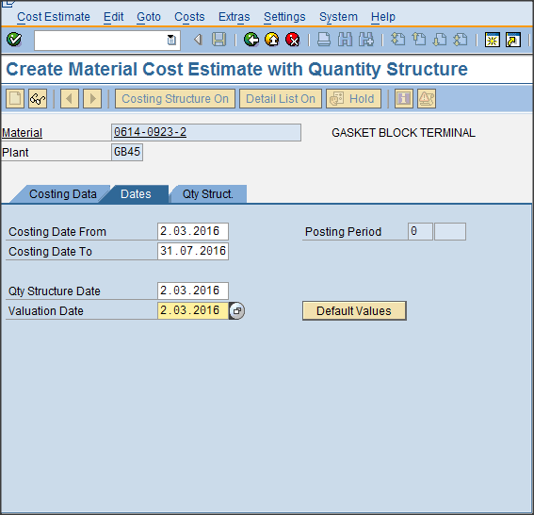
Again clicking the ‘green’ tick icon or pressing enter will move to the next screen which identifies the proposed costing output. Note:- if a cost has already be posted in the proposed period then SAP will indicate an error ‘…. Material already has a released cost estimate’. There are some useful icons which can be selected on the screen below – they will be reviewed later in this guide where the costing of multi-level BoM’s is covered.
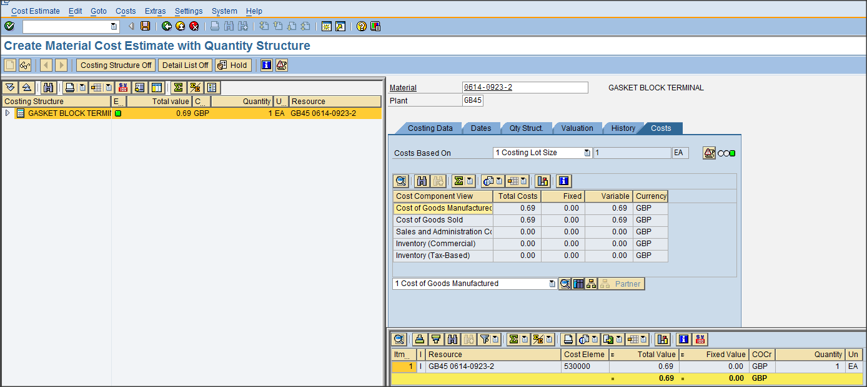
The key piece of information identified above is that the ‘green’ traffic light can be seen against the material. Note: if the system believes errors are present then either an amber (advisory) or red (error) traffic light will be seen & should be reviewed / corrected as appropriate. It should NOT be assumed that a green traffic light means the value is correct – it means that SAP has found a value!
Once the value is confirmed, click the diskette icon to save the legal cost estimate.

An ‘update parameters’ window will subsequently be seen within the main window as below.
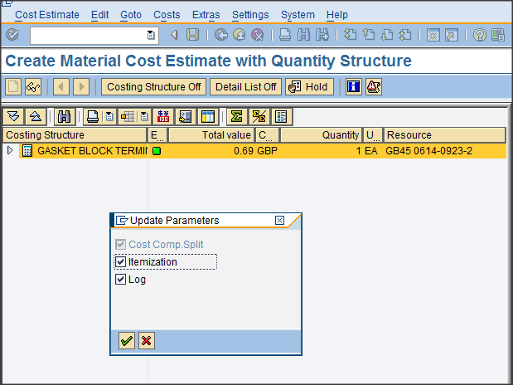
Select the ‘green’ tick to accept & the screen below will be shown.
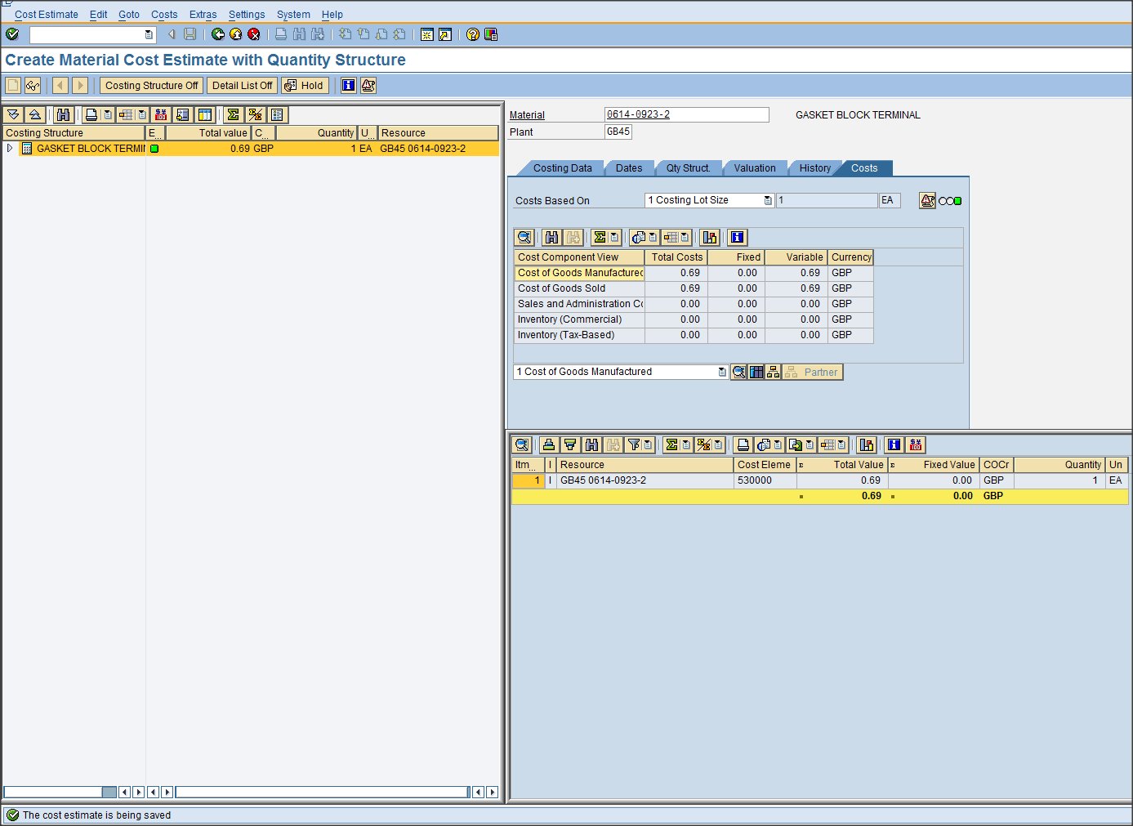
The message ‘The cost estimate is being saved’ will be seen in the bottom LH corner of the screen.

The process should then be repeated to complete the ‘Group’ valuation – for the example material in GB45, the costing variant then becomes ‘ZGBG’ as seen below.
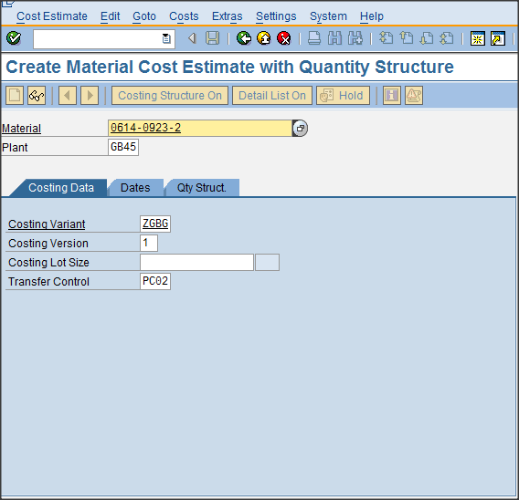
The activity using T code CK11N is now complete & can be exited using a combination of the icons.
The next steps are to ‘Mark’ & ‘Release’ the cost estimate using ‘T’ code CK24. The following initial screen is typical.

Over-write the ‘posting period / Fiscal year’ with the correct values. 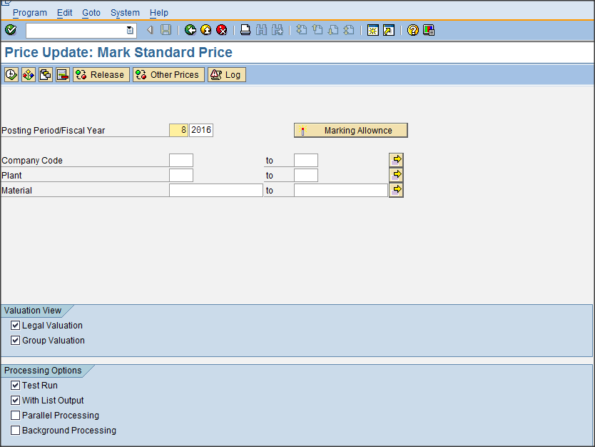
The subsequent step is to confirm whether the current period is ‘open’ by clicking on the box. As can be seen below, the red traffic lights signify that neither the Legal & Group periods are open for GB00 or indeed any other company code.
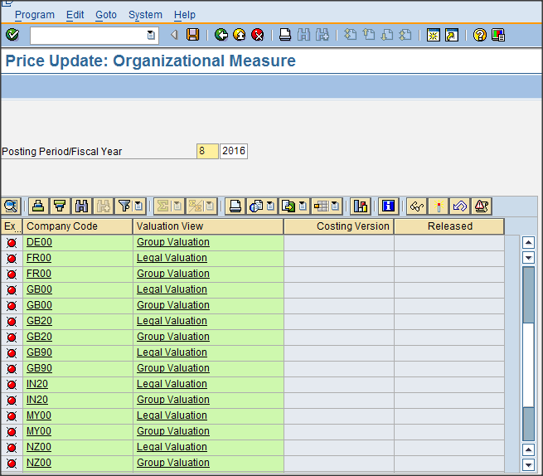
To open the period the following steps need to be completed for both ‘Group’ & ‘Legal’ – the sequence is unimportant. Click on the relevant entity to reveal the screen below – in this case GB00, Legal Valuation.
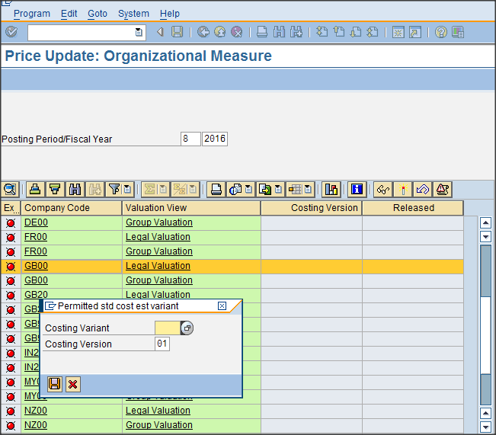
Select costing variant ZGB1 as below
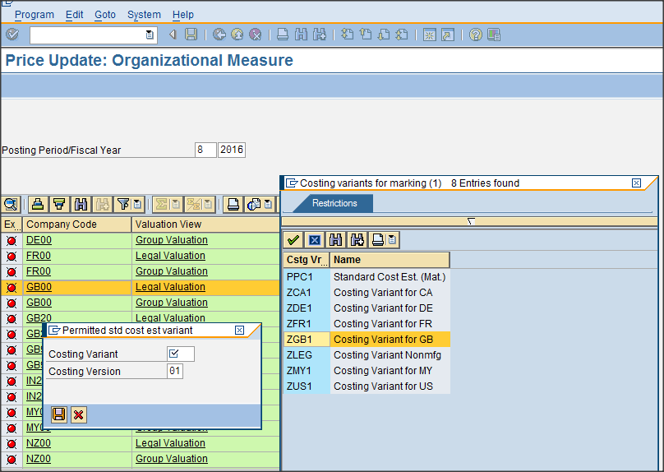
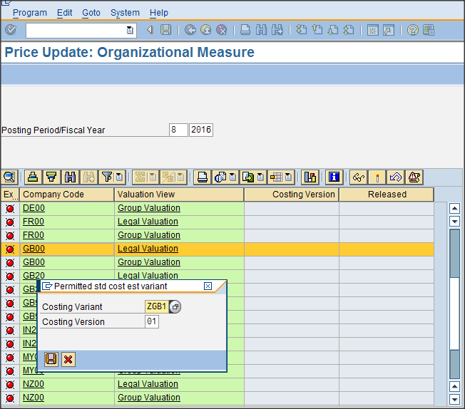
& Save
Repeat the process for the ‘Group’ valuation. The result should be ‘green’ traffic lights as below.
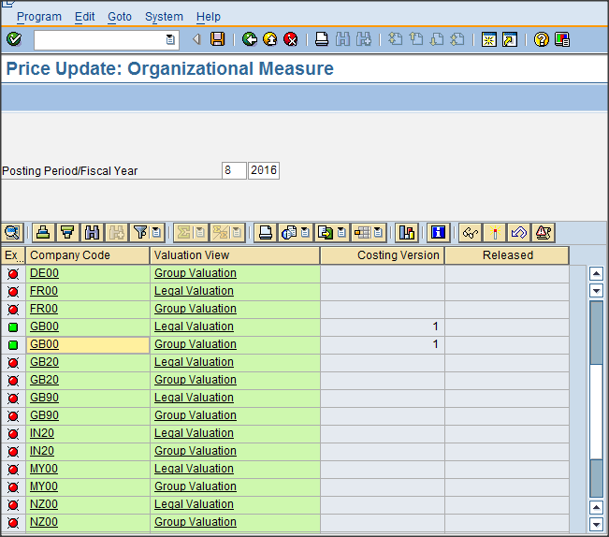
It is not necessary to press the Save Icon but doesn’t hinder the activity if undertaken.
Return to the main CK24 ‘Price Update’ screen by using the back arrow icon .
Populate the ‘Plant’ & material number as seen below.
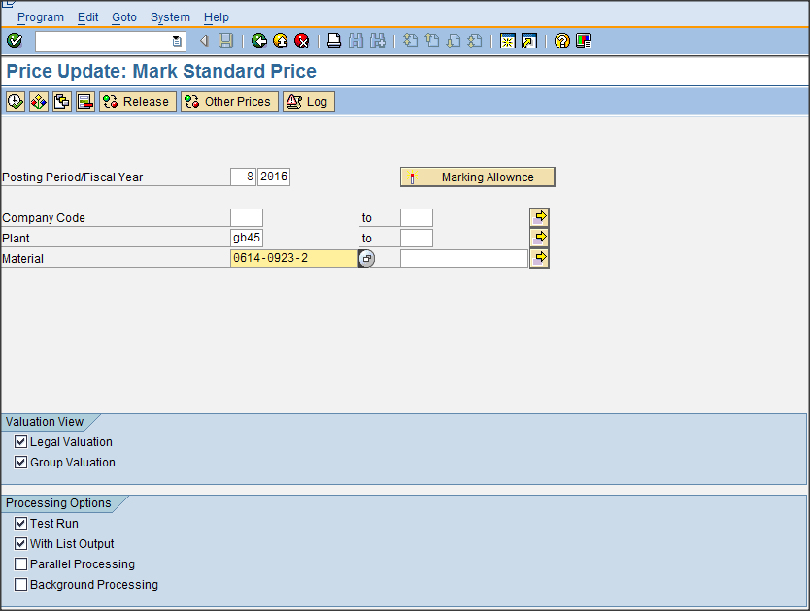
Note: to simultaneously complete both the ‘Group’ & ‘Legal’ valuations leave the boxes ‘checked’. It is also best to initially conduct the ‘Marking’ activity with a ‘test run’ to ensure the results are correct. Once the plant & material number have been entered, execute the activity using the icon

A typical post execution view is seen below.
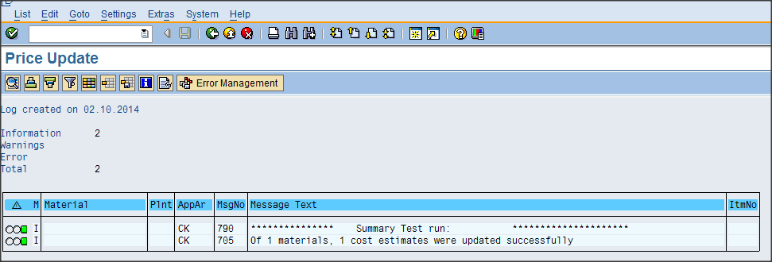
Click the back arrow to obtain a more comprehensive set of results as below.
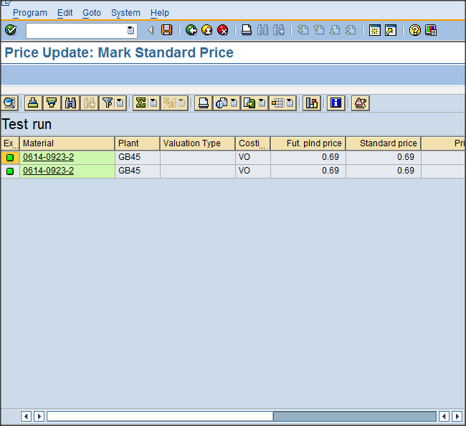
The slider bar may be moved to the right to show additional information.
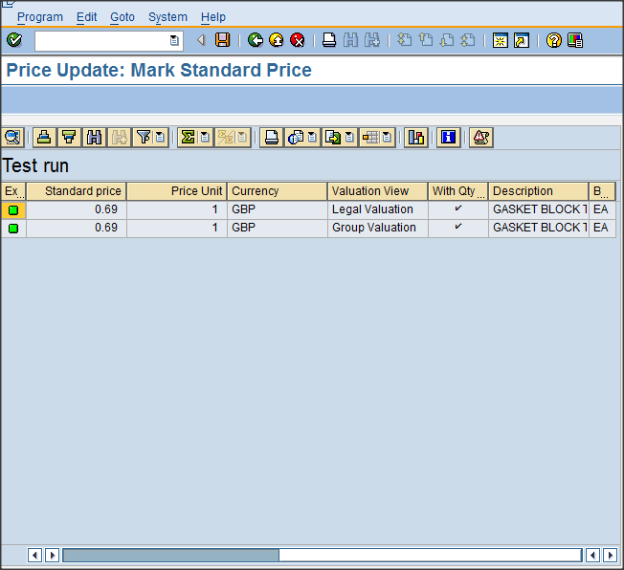

Back out using the green arrow icon & assuming the results are as expected, un-tick the ‘test run’ option – see below.
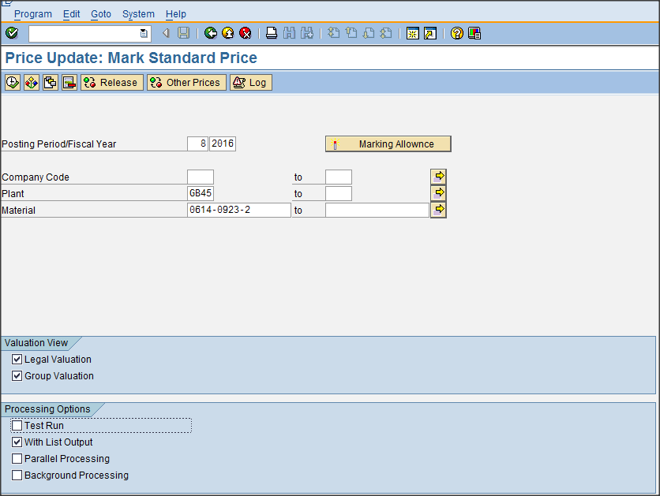
Repeat the ‘execute’ process & the following screen is seen.
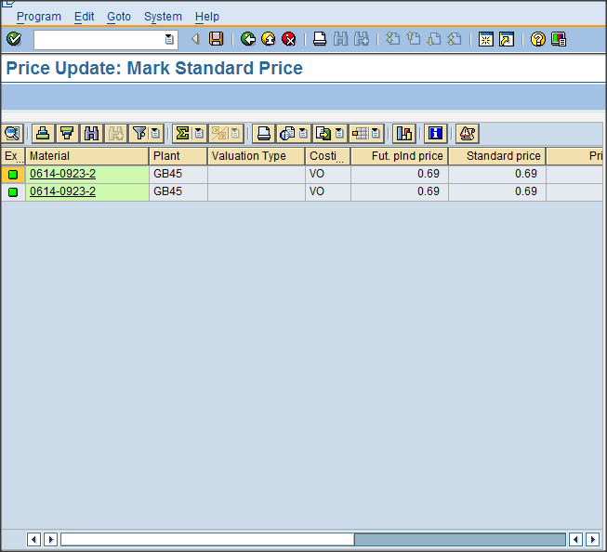

The ‘Legal’ & ‘Group’ future costs will now be posted & visible in Material Master (T code MM03), Costing 2 tab (again it is not necessary to click the Save icon ) – see screen shot below showing future cost estimate in MM with period / fiscal year.
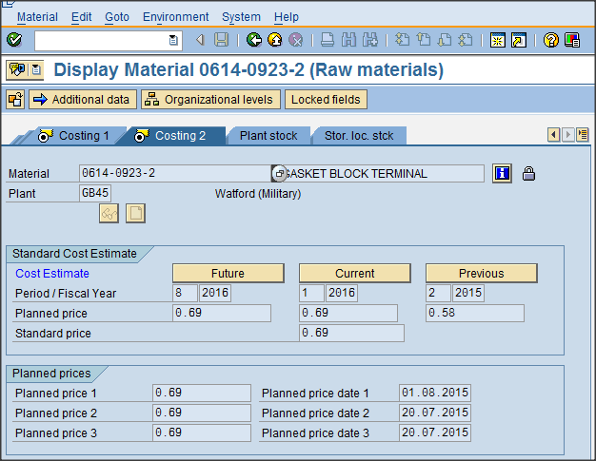
Return to & back out of the CK24 ‘Price update’ screen using the green back arrow. The last step is to release the new Group & Legal standards.
Return to the CK24 screen & select ‘Release’ leaving the other settings (i.e. no test run required)
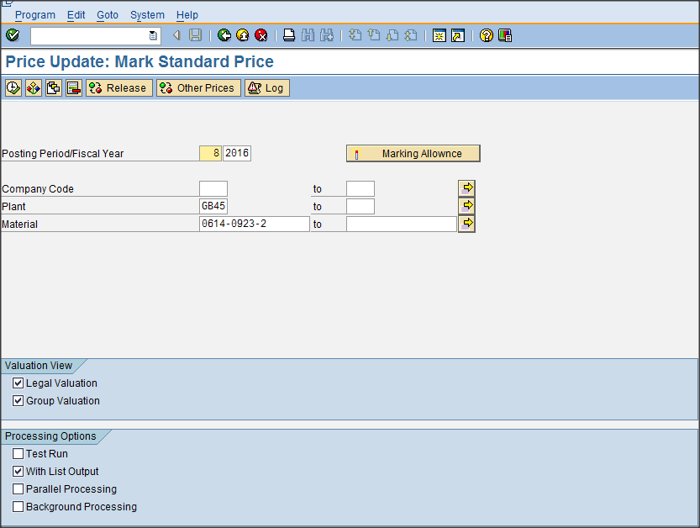
The following screen is seen - click the execute Icon
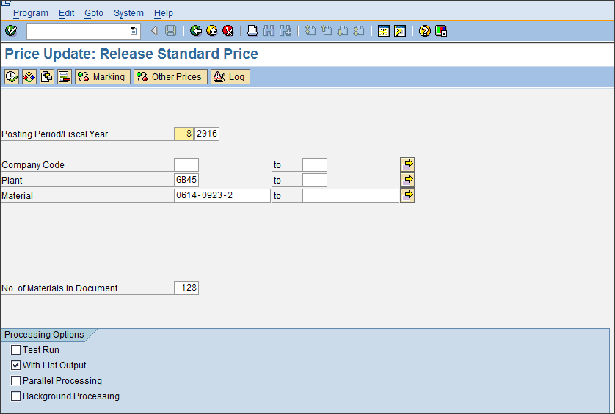
If the activity is successful, the following screen will be displayed – note the message ‘Of 1 materials , 1 cost estimates were updated successfully’.
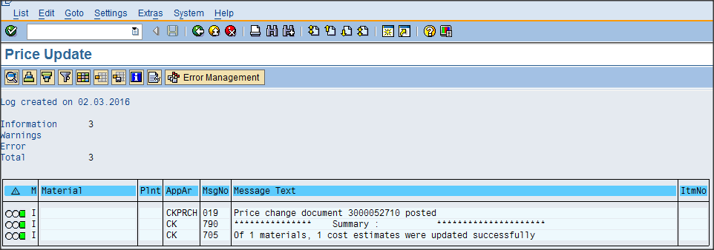
Back out using the green back arrow icon to reveal the detailed results.
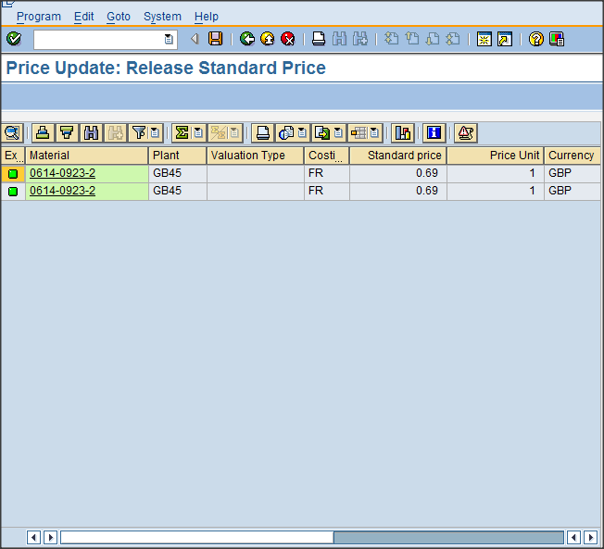
Exit the transaction & review the released posting in Material Master (T code MM03), Costing 2 tab which now shows the current period, year & value.
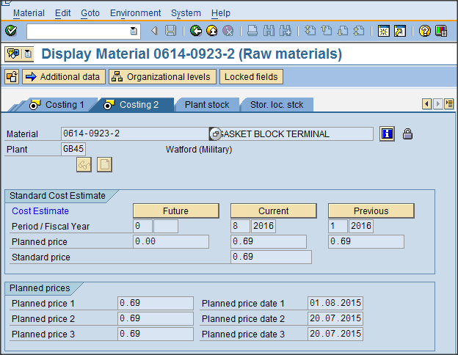
The cost roll activity for a single material is now complete & confirmed.
==================================================================================
Process to cost roll a group of materials.
If the user wishes to conduct & ‘post’ a cost roll for a group of materials or multi-level BoM including all ‘children’ the steps are similar to those described above but with the following variation.
Within ‘T’ code CK11N ensure that the PC02 flag is removed (it may take a couple of attempts to finally remove!).
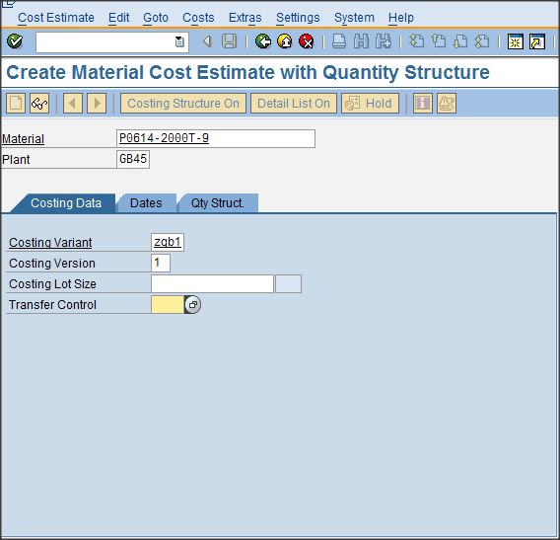
Note the use of new finished goods material, P0614-2000T-9 which contains a multi- level BoM & in-house labour to manufacture. As can be seen below, the result of running T code CK11N provides the first level of the costed BoM.
- to expand the costed BoM, Click the ‘down arrow’ icon
- to show the labour content click the ‘book’ Icon
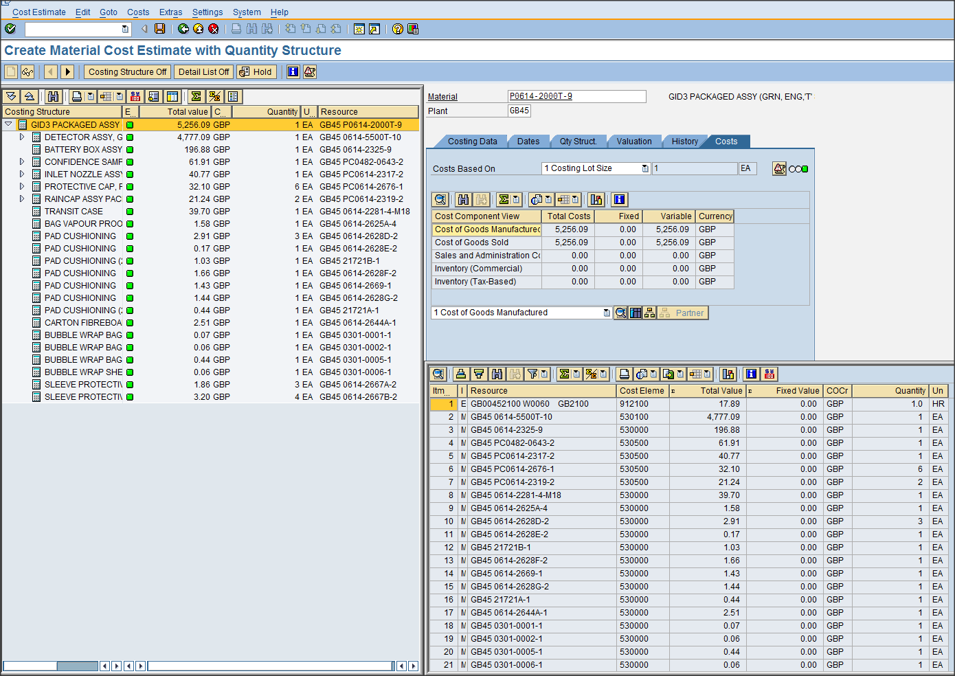
The result of opening up the full BoM & labour can be seen below.
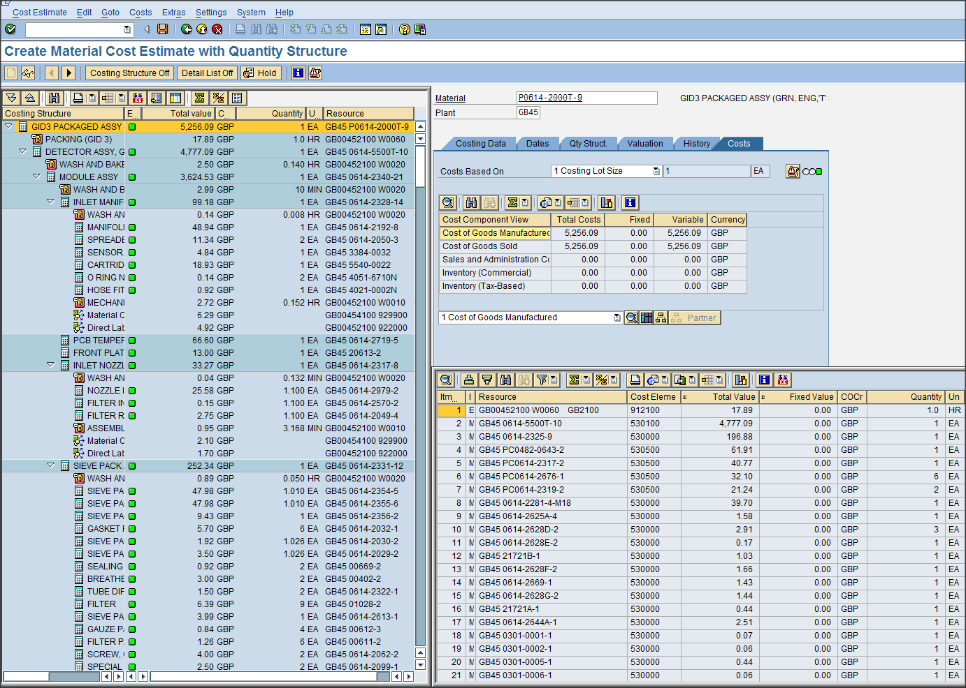
The ‘wiggly’ worm icon identifies labour activity – the adjacent text provides a description of the activity, associated cost & labour in hours (may also be shown in minutes).
In this instance, the BoM shows a full complement of ‘green’ traffic lights but remember ‘green’ does not necessarily mean they are correct. See notes at the end of this guide which hopefully describe some possible pit-falls.
If amber or red errors are seen, SAP provides assistance to resolve although messages are often very convoluted. To review the errors, double click on the delinquent ‘red’ traffic light material: in this instance, 0614-2192-8 has been used as an example, but does not actually contain an error. This will provide bespoke material information in the RH window & if errors are present, the following icon will be seen  in this location.
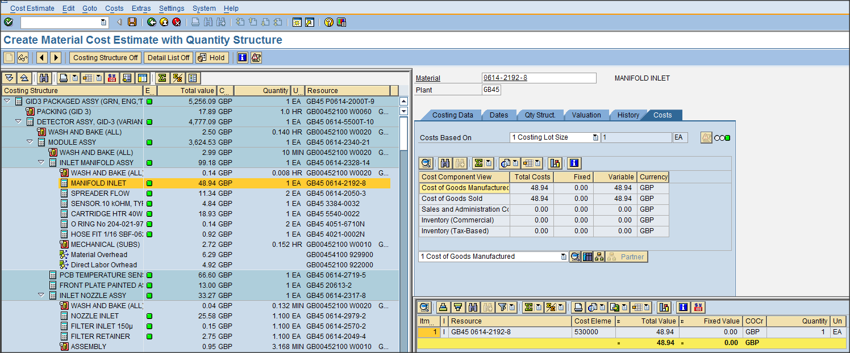
Double clicking on the icon will reveal the error in more detail as seen below for an alternative material
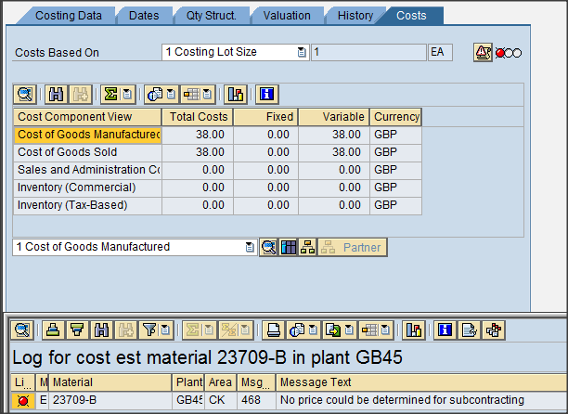
The subcontract reference can be seen in a costed BoM with a small truck or van icon . See further example below.
This indicates that SAP is waiting for a Sub-con PIR (costs)
If a breakdown of material, labour & overheads are required then the following icon is useful.
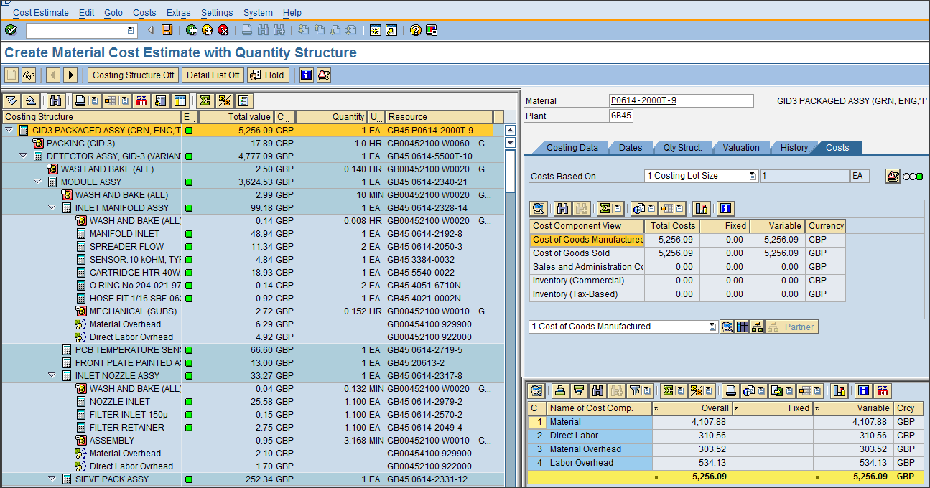
Once the costs shown in the multi-level BoM have been confirmed as accurate, then CK24 should be used as described in the steps for a single material recognising that the full, multi-level product BoM should be copied into the ‘price update’ screen.
The full product BoM can be extracted from SAP using T code ‘ZSCM_BOMECM’ – individuals may not have access to this transaction but the typical steps to generate are seen below for material P0614-2000T-9.
Entering T code ‘ZSCM_BOMECM’ into the SAP dialogue box reveals the following – note the populated fields including suppress leading zeros.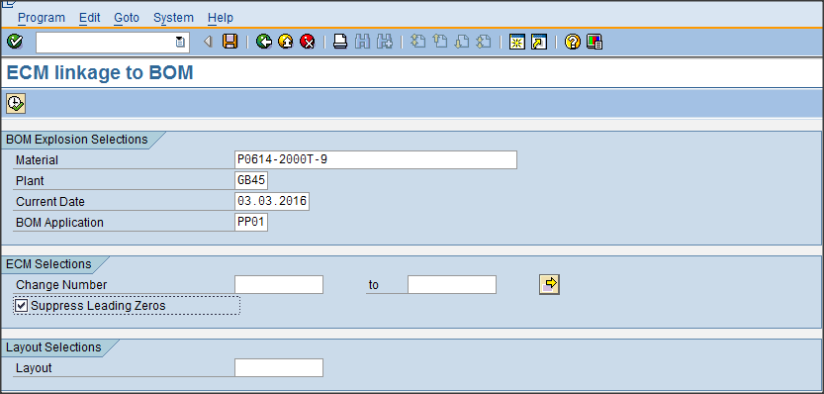
Click the Execute Icon to reveal the full BoM – snapshot shown below.
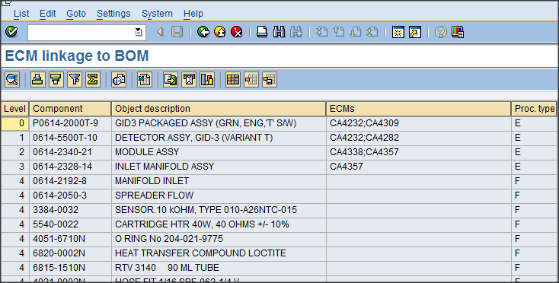
Use ‘Control Y’ & ‘Control C’ to select all of the materials in the ‘Component’ column. These can then be posted into the CK24 screen.
The different steps are as follows:-
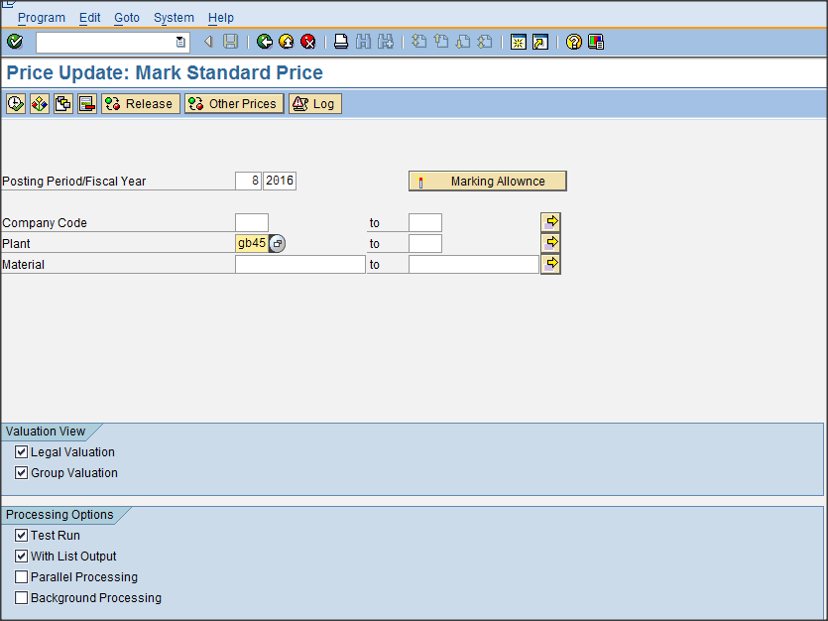
Click on the mass input of materials icon to reveal the following screen.

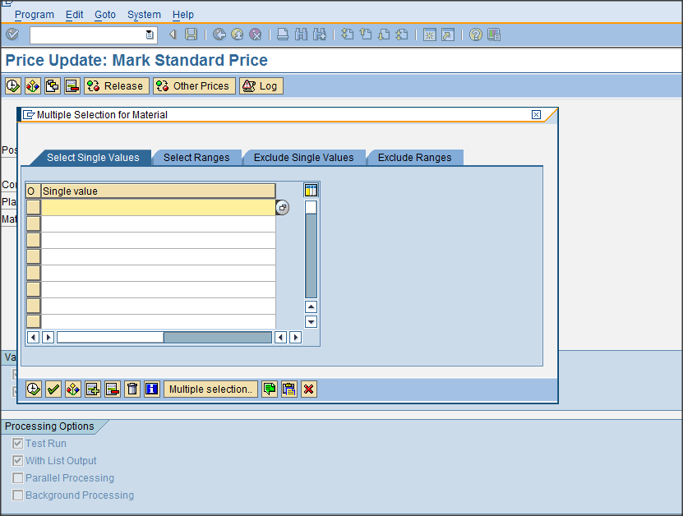
Select the ‘single values tab’ where the ‘Upload from clipboard’ icon should be used. Note:- It is best not to use the ‘Control V’ option as this may not paste the entire BoM.
The result will be as follows – note that the ‘Select single values’ tab now shows the quantity of pasted items as 400.
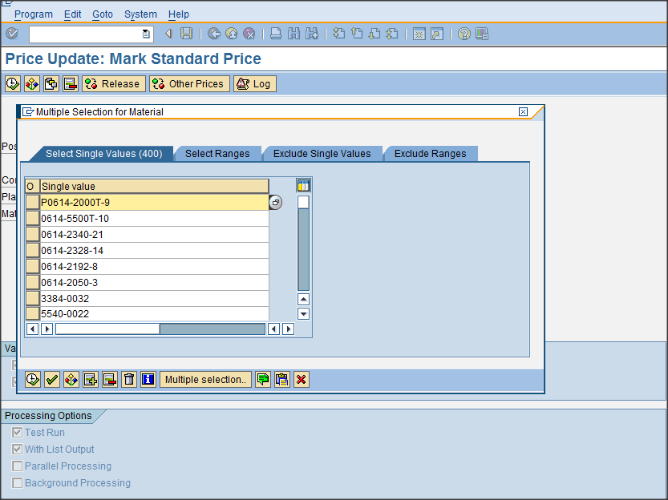
Click the execute icon to finally copy the values.
The steps previously defined for CK24 ‘Mark’ & ‘Release’ may now be followed.

Note that the results shown below no longer indicate ‘1 of 1 materials…..’ but in this instance 294 materials have been successfully updated. The difference between 400 pasted items & 294 ‘successes’ are attributed to duplicate materials in the multi-level BoM or materials already posted in this period.
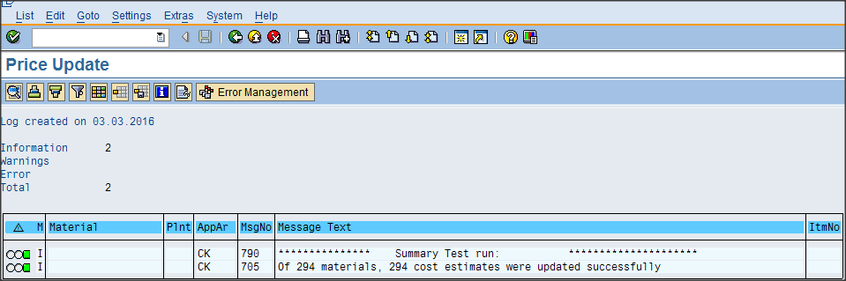

Items to consider when setting a standard cost

Requests to set a standard are likely to result from:-
  - Material extensions to multiple sites completed by GDG. The requests are currently via an e-mail (group or individual)
  - Site controllers advising that the current standards are completely in error eg material currently valued at $0.01 now cost rolled & posted at $1115.14
  - New products, spares or service materials loaded to SAP
  - Annual group cost roll.
Consideration should be given to:-
- Is the Material Type correctly set – if not, then STO uplifts will be incorrect.
- Is the source of supply correctly set in the receiving plants material master record?
- Is the cost correctly ‘posted’ in the plant identified as the source of supply, has it been formally cost rolled or just manually posted – manually posted costs are unacceptable.
- Check that the costs posted costs are correct, maybe review PIR’s, MB51 for recent receipts
- Check the costing lot size – if greater than 1, this may require further review to set a 1 off cost in the receiving plant
- Check the Price Unit – if greater than 1, this may require further review to set a 1 off cost in the receiving plant
- Have values been correctly set for Planned Price 2 & 3 in the receiving plants material master data. This will be based on the material type, plant to plant uplift & currency conversion.
- Currency conversion to be completed using the budget rate.
- If there is any doubt about the costs in the supplying plant then conduct a CK11N review. If appropriate, ask the site financial controller to post a new value.
- Is there stock in either plant – be aware that setting a new standard will result in a re-valuation which may be unacceptable.
- Consider when it is appropriate to set a new standard, for example, if a material valuation was generated in period 1 but a massive change in the build programme has resulted in dramatically different costs. This may result in a massive PPV
- Costs in the same entity for the same material should be identical eg GB00 = GB30 & GB45, US00 = US45, US65 & US80
- An identical STO material in the same entity should indicate the same source of supply using the Special Procurement Key in MM, MRP2. Note, the SPK code will, by necessity, be different.
- Problems may be experience around month end when attempting to post standards: either complete before closure or shortly after the new period is opened.

- RESPONSIBILITIES

- All Cost-rolls for extensions of materials must be carried out by the Data Governance team
- All Changes to existing standard prices for US materials is carried out and signed off by senior Finance & Operations representatives.
- All changes to existing standard prices for materials for the remaining plants are carried out by and signed off by the local Finance Operations.

- DATA GOVERNANCE PROCESS
THE GOVERNANCE PROCESS NEEDS TO BE CONFIRMED WITH THE FINANCE TEAM – IF A STANDARD PRICE CHANGES IN ONE MANUFACTURING SITE, HOW IS THIS CHANGE EXTENDED TO THE OTHER SITES.
- Cost-roll is reviewed annually by the Finance team.
- Individual materials are cost-rolled whenever the material is extended to another plant or when a new material is created in the system.
- Monthly Audit reports are run by GDG to monitor all newly extended materials have been cost-rolled.

